API Security Testing Report
1.Objective
The purpose of this assessment was to inspect a public API endpoint using Postman and identify potential security vulnerabilities related to authentication mechanisms, HTTP headers, exposure of sensitive response data, and overall API security practices.
2. API Information
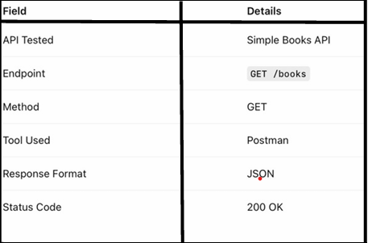
3. Authentication Inspection
Observation
The API endpoint did not require any authentication or authorization mechanism to access the data. The request was completed successfully without the need for:
- An API key
- A Bearer token
- Login credentials
- Any form of authorization verification
This indicates that the endpoint is publicly accessible without access restrictions.
Security Impact
Publicly accessible API endpoints may allow unauthorized users to retrieve sensitive or internal data without proper restrictions. This can increase the risk of data exposure, misuse of the API, unauthorized access, and potential abuse by malicious users.
4. Headers Inspection
The request and response headers were inspected using Postman to analyze the communication between the client and the API server.
Observed Headers
- Content-Type
- Accept
- Host
- User-Agent
Observation
Standard HTTP headers were present in both the request and response. The API responded successfully in JSON format, indicating proper handling of content negotiation and standard client-server communication practices.
5. Response Data Inspection
The API returned structured JSON data containing information related to books.
Sample Response
{
"id": 1,
"name": "The Russian",
"type": "fiction",
"available": true
}
Observation
The response data was properly structured, readable, and successfully returned by the server in JSON format. The API response contained clearly defined fields and demonstrated consistent data formatting.
6. Identified Security Risks
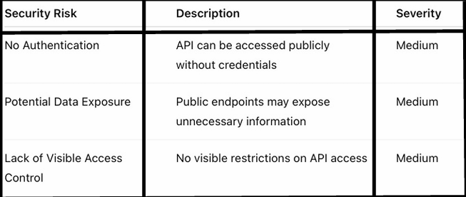
7. Risk Severity Classification
Risk Level: Medium
The API allows unrestricted public access without requiring authentication or authorization. Although the tested endpoint currently exposes only book-related information, the absence of proper access control mechanisms could pose security risks if similar practices are applied to sensitive or confidential APIs.
Security Concern
Without authentication controls, unauthorized users may be able to access, retrieve, or misuse data. Implementing stronger security measures such as API keys, token-based authentication, and access control policies is recommended to enhance API security and prevent unauthorized access.
8. Recommended Remediation Steps
To improve the security of the API, the following remediation measures are recommended:
- Implement proper API authentication mechanisms such as:
  - API Keys
  - Bearer Tokens
  - OAuth Authentication
- Apply rate limiting to reduce abuse, spam requests, and automated attacks.
- Restrict sensitive API endpoints to authenticated and authorized users only.
- Return only the necessary response data to minimize unnecessary data exposure.
- Monitor and log API traffic regularly to detect suspicious or unusual activities.
- Implement proper access control and validation mechanisms to enhance overall API security.

Postman API Security Assessment

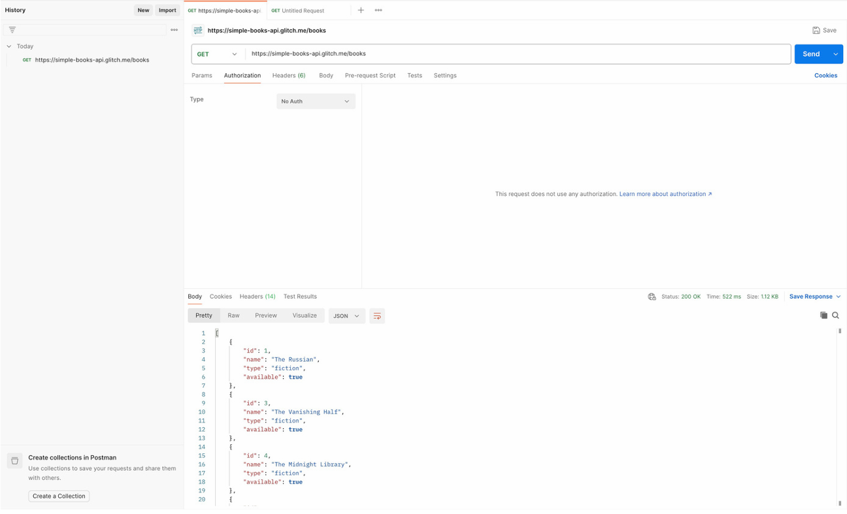
9. Conclusion
The API endpoint was successfully tested using Postman. The endpoint responded correctly with a 200 OK status and returned valid JSON data, indicating that the API was functioning properly.
However, the API did not require any authentication or authorization mechanisms, which could result in unauthorized public access if sensitive information is exposed through current or future endpoints.
To strengthen overall API security, it is recommended to implement proper authentication, authorization, and access control mechanisms. Additional security measures such as rate limiting, traffic monitoring, and response data minimization should also be considered to reduce potential security risks.

